Demo the proof-of-life function varying the rate of message losses.

Also, to demonstrate the impact of Byzantine nodes (to some extent)

you can allow up to f nodes being silent (not participating).

Show how this impacts nodes crashing themselves.

1 connection with broadcast

Every process that did not receive any message relative to a broadcast, executes the proof-of-life function

2 process:

3demoing

1. Run the simulation

First, in the process of initialization, each node generate a heart beat and send it in the form of broadcast.

Demo the proof-of-life function varying the rate of message losses.

basics of fault tolerance

the need for 3f+1 replicas and such

Results/achievements/challenges

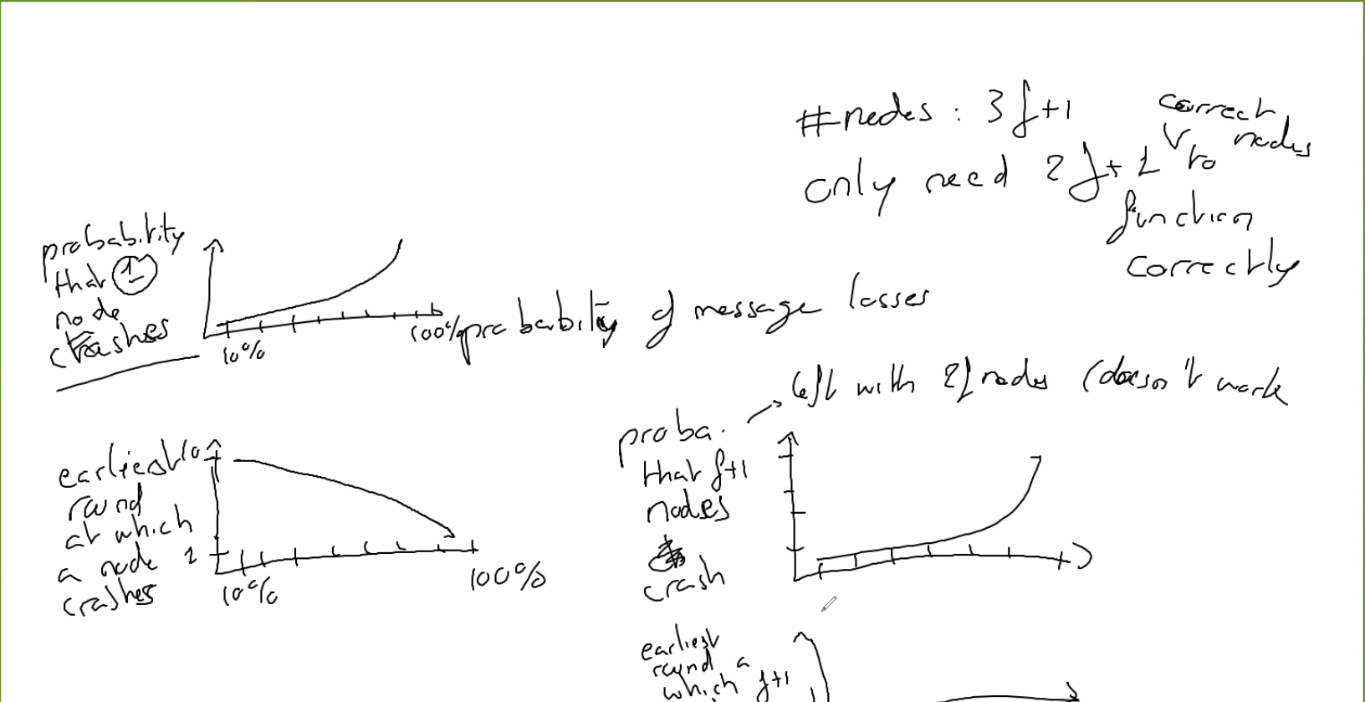

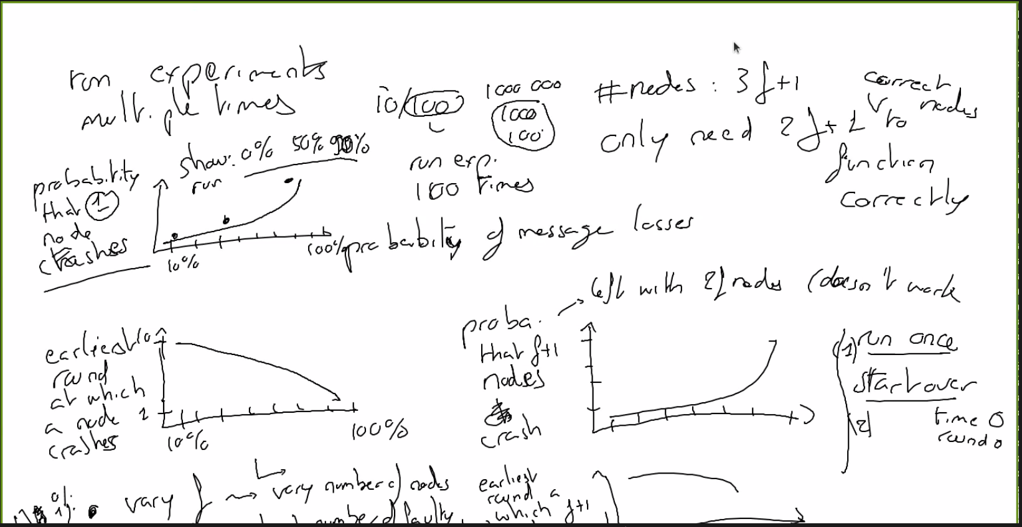

[General]network = FullyConnectedsimtime-resolution = ms #us # time in microseconds#num-rngs = 10#seed-set = 6repeat = 100omnetpp.ini

Plans and slides

Figure 1

100 runs-10communation rounds

x-message loss

y-probability of a node crash

Figure 2

100 runs-10communation rounds

x-message loss

y-earliest round a node crashes